**Homework 6**

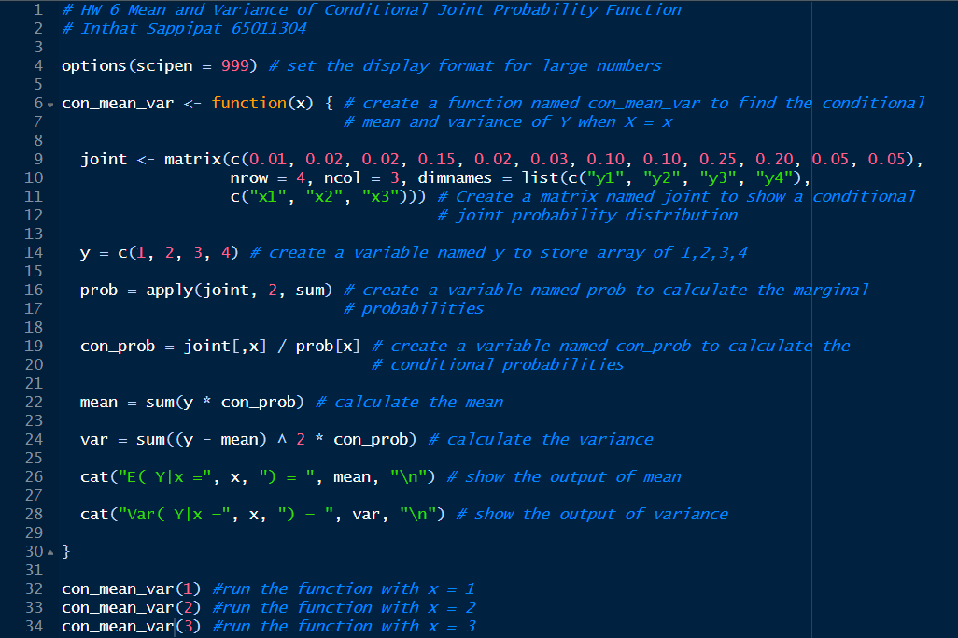**Code:**

**Result:**

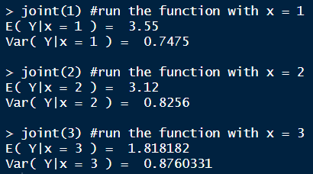

**Conclusion:**

From the experiment, the conditional mean and variance of Y when X = 1 are 3.55 and 0.7475, the conditional mean and variance of Y when X = 2 are 3.12 and 0.8256, and the conditional mean and variance of Y when X = 3 are 1.818182 and 0.8760331. Comparing these to the result that comes from the calculator is the same. In my opinion, the function that I created and the theoretical calculations are consistent.